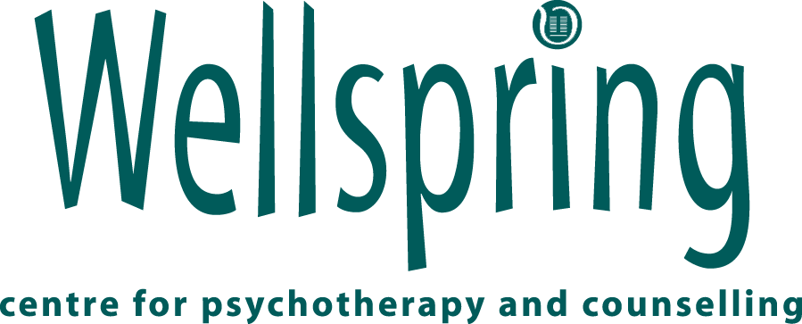

Counsellor/Psychotherapist
Application Form

This information will be held in the strictest confidence and unsuccessful applications destroyed.

Personal Information

First Initial: |  | Surname:
Address: |  | Home Tel:
Address: |  | Work Tel:
Postcode: |  | Mobile:
Email:

Eligible to work as a self- employed therapist in Scotland.

If successful, what days/hours are you available to work?

Please state the earliest date you could start:

Do you have any holidays booked? If you do, please state the dates:

Declaration

I confirm that the information I have given is, to the best of my knowledge, true and complete.

Signature: Date:

Please do not include any other information with your application, i.e., CV’s, certificates etc.

Completed applications should be emailed to: maggie@wellspring-scotland.co.uk and corinna@wellspring-scotland.co.uk

Education and Training

Art Therapy/Counselling/Psychotherapy Training
Training Institution | Qualification | Date Awarded

Other Qualifications/training
Training Institution | Qualification | Date Awarded

Continuing Professional Development
Training Institution | Course/Workshop | Duration | Dates

Employment History
Please give a brief summary of your non-therapy related employment history
Employer | Job Title | Dates

Clinical Practice

- When did you start practising?

- Total number of practice hours per year:

- Name and orientation of supervisor(s):

- Number of supervision hours per year:

- Give details of your counselling/psychotherapy work experience, including the range of your clinical experience: i.e., client groups, specialist areas, long/short-term work? (300 words maximum)

- Outline your theoretical approach and describe how it underpins your clinical practice. (300 words maximum)

Personal Therapy

How has the experience of therapy affected you personally & professionally? Please give orientation(s) and dates. (300 words maximum)

Additional Information

Why do you want to work at Wellspring? (300 words maximum)

Conflict of Interest/Dual Roles:

Do you, or have you had a relationship with anyone in Wellspring (see website for all of our staff therapists, volunteers and Board members) such as supervision, therapy or personal? Yes/No

If yes who……………………………………………………………………………………………

Accreditation/Recognition

Are you accredited? Yes/No
Are you working towards accreditation? Yes/No
Please give details of accredited body and accrediting status with dates where appropriate:

Membership of Professional Bodies
Please state which professional organisation(s) you are a member of, with category of membership and dates:

Have you ever been removed from a professional or other register? Yes/No
If yes, please give details:

Are you currently registered as self-employed? Yes/No

Rehabilitation of Offenders Act 1974

Under the provisions of the above Act do you wish to bring to our attention any conviction, whether spent or unspent? Yes/No
If yes, please give details:

PVG Scheme Records
Due to the confidential nature of our work, the successful applicant will require a
PVG Scheme Record. Do you have PVG Scheme Record? Yes/No

0305/001

Professional Referee (1) Professional Referee (2)
Name Name

Address Address

Tel Number(s): Tel Number(s):
Email: Email:

Revised July 2022

Wellspring (Scotland) Ltd
13 Smith’s Place
Edinburgh EH6 8NT
0131 553 6660
www.wellspring-scotland.co.uk
Reg no: 168948 Charity no: SCO 12522

